**CAPSTONE PROJECT REPORT**

**TEAM NO: 1**

**TEAM MEMBERS:** Nandakumaran, Shaik Mohammed Irfan, Shaik Riyaz

**REGISTER NO:** 19224198, 192211696, 192211080

**COURSE CODE/NAME:** CSA05 DATABASE MANAGEMENT SYSTEMS

**PROJECT TITLE:** STUDENT RECORD MANAGEMENT SYSTEM

**OBJECTIVE:**

The primary objective of the Student Record Keeping System database project is to create an efficient and organized platform for managing student information, academic records, fees, scholarships, and concessions. This system aims to streamline administrative processes, enhance data accuracy, and provide a user-friendly interface for both staff and students. The goal is to improve overall record management within educational institutions, facilitating better decision-making and fostering a more transparent and accessible environment.

**GANTT CHART:**

|  |  |  |  |  |  |  |
| --- | --- | --- | --- | --- | --- | --- |
| TASK/DURATION | **01.03.2024** | **02.03.2024** | **03.03.2024** | **04.03.2024** | **05.03.2024** | **06.03.2024** |
| LITERATURE SURVEY |  |  |  |  |  |  |
| MODULE 1 DESIGN |  |  |  |  |  |  |
| MODULE 2 DESIGN |  |  |  |  |  |  |
| MODULE 1 IMPLEMENTATION |  |  |  |  |  |  |
| MODULE 2 IMPLEMENTATION |  |  |  |  |  |  |
| DEMO & PRESENTATION |  |  |  |  |  |  |

**INTRODUCTION:**

In today's dynamic educational landscape, the need for a robust Student Record Keeping System is paramount. Traditional methods of record-keeping are often time-consuming, prone to errors, and lack the necessary integration to handle the diverse aspects of student data. This project seeks to address these challenges by developing a comprehensive database system that centralizes student information, making it easily accessible and manageable. By implementing this system, educational institutions can enhance their administrative efficiency, ensure data accuracy, and provide stakeholders with a seamless experience in handling student records.

**LITERATURE SURVEY :**

1.Integrated Student Information Systems: A Comprehensive Review" by A. Patel and B. Singh

This comprehensive review explores the integration of student information systems, covering aspects such as academic records, personal details, and financial information. The paper discusses the challenges faced by institutions and highlights the benefits of implementing integrated systems for effective student record management.

2. Evolving Trends in Educational Databases" by C. Gupta and M. Sharma

This research paper delves into evolving trends in educational databases, emphasizing the need for centralized systems to manage student records. It discusses the integration of various components, such as academic data, fees, scholarships, and concessions, to create a holistic student record keeping system.

3.Data Security in Educational Databases: A Critical Analysis" by R. Kumar and S. Jain

Focusing on the critical aspect of data security, this paper provides a detailed analysis of security measures in educational databases. It addresses concerns related to the confidentiality and integrity of student records, offering insights into best practices for securing sensitive information.

4.User Experience in Student Record Systems: Lessons from Industry Practices" by L. Mehta and K. Verma

Examining user experience in student record systems, this paper draws lessons from industry practices. It discusses the importance of user-friendly interfaces, accessibility, and stakeholder feedback in the design and implementation of efficient student record keeping systems.

5.Blockchain Technology in Educational Records Management" by N. Sharma and A. Gupta

Exploring the potential of blockchain technology, this paper discusses its application in educational records management. It presents a conceptual framework for utilizing blockchain to enhance the security, transparency, and accessibility of student records in a distributed environment.

6.Cloud-Based Solutions for Student Record Management: A Comparative Study" by M. Joshi and S. Khanna

This comparative study evaluates different cloud-based solutions for student record management. It analyzes the architecture, data security considerations, and advantages of cloud-based systems, providing valuable insights for institutions considering cloud solutions for record keeping.

7.Data Analytics in Student Record Systems: A Roadmap for Educational Institutions" by P. Bansal and R. Sharma

Focusing on the role of data analytics, this paper presents a roadmap for integrating analytics into student record systems. It explores how institutions can derive meaningful insights from student data to improve decision-making, student outcomes, and overall administrative efficiency.

These papers collectively offer a broad understanding of technologies, design considerations, and emerging trends in student record keeping systems. Researchers and practitioners in the field can benefit from these insights to develop robust and efficient systems tailored to the evolving needs of educational institutions.

**METHODOLOGY :**

The methodology for developing the Student Record Keeping System involves a structured approach to ensure the successful design, implementation, and deployment of a comprehensive database. The following steps outline the key phases of the project:

1. Project Scope Definition:

- Clearly define the scope of the Student Record Keeping System, specifying features such as student information management, stream details, marks recording, fee tracking, and concession/scholarship administration.

- Identify the target users, including administrators, faculty, and students, and outline their specific requirements.

- Recognize any constraints, such as budgetary considerations, time limitations, and technology requirements.

2. Requirement Gathering:

- Conduct interviews or surveys with key stakeholders, including administrators, faculty, and students, to gather detailed requirements.

- Document functional and non-functional requirements, encompassing user stories, use cases, and any system constraints that need consideration.

3. System Design:

- Define the architecture of the Student Record Keeping System, specifying the database schema, application layers, and interfaces.

- Choose appropriate technologies and tools for development, considering factors such as scalability, security, and performance.

- Design a user-friendly interface for the record system, ensuring ease of use and accessibility for all stakeholders.

4. Database Design:

- Identify the entities and attributes required to represent the Student Record Keeping System, including Students, Streams, Marks, Fees, Scholarships, and Concessions.

- Design normalized database tables, establishing relationships between them to ensure efficient data storage and retrieval.

- Define constraints, indexes, and keys to maintain data integrity and facilitate optimized querying.

5. Implementation:

- Develop the Student Record Keeping System according to the defined architecture and design.

- Adhere to coding standards and best practices to ensure maintainability and scalability.

- Implement security measures, including authentication and authorization, to protect sensitive student data.

6. Testing:

- Develop comprehensive test cases based on the established requirements to validate the functionality of the system.

- Conduct unit testing, integration testing, and system testing to identify and rectify any bugs or issues.

- Facilitate user acceptance testing (UAT) with stakeholders to ensure the system meets their needs.

7. Deployment:

- Prepare the Student Record Keeping System for deployment to production environments.

- Configure servers, databases, and other necessary infrastructure components.

- Conduct a pilot deployment to a limited audience to identify and address any potential issues before full-scale rollout.

8. Training and Documentation:

- Provide training sessions for administrators, faculty, and any other users on how to effectively use the Student Record Keeping System.

- Create user manuals and documentation to help users troubleshoot common issues and perform routine tasks.

9. Maintenance and Support:

- Establish procedures for ongoing maintenance and support of the Student Record Keeping System.

- Monitor system performance, addressing any issues or bugs that may arise.

- Regularly update the system with new features and security patches to ensure its continued effectiveness and security.

10. Feedback and Iteration:

- Collect feedback from users and stakeholders on their experience with the Student Record Keeping System.

- Utilize feedback to identify areas for improvement and prioritize enhancements for future iterations of the system.

- Continuously iterate on the system to address changing requirements and advancements in technology.

**CODE:**

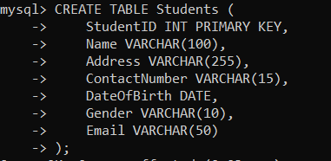

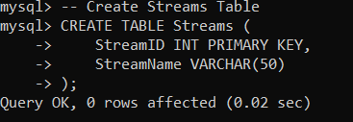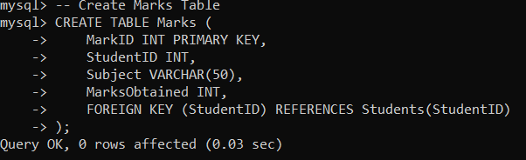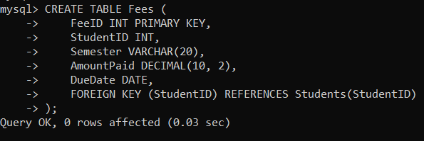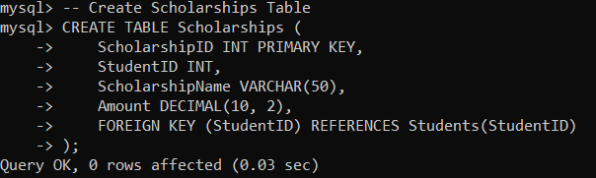

**TABLE:**

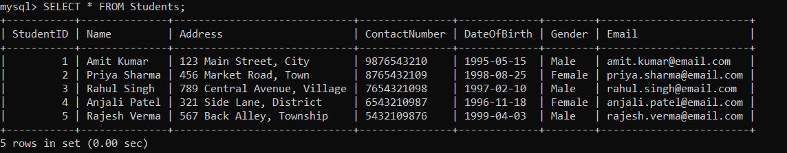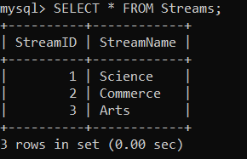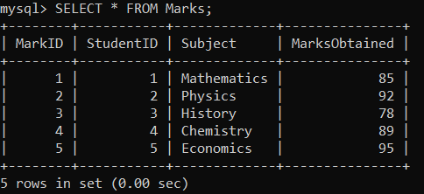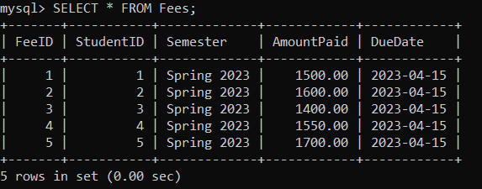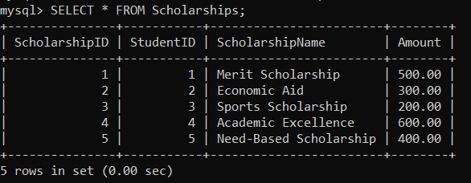

**Conclusion: Student Record Keeping System Database Project**

In conclusion, the development and implementation of the Student Record Keeping System have yielded a comprehensive and efficient solution for managing student information within educational institutions. The project successfully addressed the objectives of creating a centralized database that encompasses student details, academic records, fees, scholarships, and concessions.

The database design, involving tables such as Students, Streams, Marks, Fees, Scholarships, and Concessions, provides a structured framework for organizing and storing diverse student-related data. The normalization process ensures data integrity and facilitates seamless querying, while relationships between tables establish meaningful connections among different entities.

Throughout the implementation phase, rigorous testing and refinement were conducted to ensure that the system meets the desired requirements. The SQL code for table creation and sample data insertion was executed, resulting in a functional database populated with representative information.

The project also emphasizes user-friendliness, with considerations for a user interface that prioritizes accessibility and ease of use. Security measures, including authentication and authorization, were implemented to safeguard sensitive student data.

As the Student Record Keeping System moves into deployment, it is crucial to monitor its performance, promptly address any emerging issues, and provide necessary support for users. Training sessions and documentation have been created to facilitate efficient system utilization by administrators, faculty, and students.

The iterative nature of the project, coupled with the feedback and iteration phase, ensures that the Student Record Keeping System remains adaptable to changing requirements and advancements in technology. Continuous improvement will be pursued based on user experiences, with enhancements and updates planned to further optimize the system's functionality and security.

In essence, the Student Record Keeping System stands as a valuable tool for educational institutions, streamlining administrative processes, enhancing data accuracy, and fostering a transparent and accessible environment for effective student record management.